This chapter discusses on the overall Backpropagation algorithm and different ways to improve it further which gives a further chance to work on this topic.

This program developed on Linux OS (Ubuntu version 9.10) on gcc compiler(inbuilt on linux platform). Although the overall performance is good but sometimes due to higher value of lamda the program hangs and I had to restart it. Though there is no fixed value of lamda for particular data set ,this can be a very good research work if someboby wants to have generalized conception or range of values of lamda which is suitable.
Again, there is only one hidden layer in this program. One may start with one hidden layer and introduce another hidden layer and check the differences in result.Somebody , may start his work with multiple hidden layers (i.e. 2 or 3) and observe the changes in the program or initial errors in training set and final error in test set. But it is very difficult to generalize the total program if somebody uses multiple hidden layers. The real problem comes in backpropagation during updation of weights. But if somebody can develop , it will definitely be a very good work, because generalizing the updating factor or finding out delta for each layer is really an uphill task for someone that too in online method. Surely, the computational complexity will rise because every time the vectors has to traverse all through the network and come back again for weight updation.

Activation function used in this program is sigmoid function.
It is expressed in the form:
f(x) = 1/(1 + e^{-ax});
A graph of this function is shown in Figure 1 following:

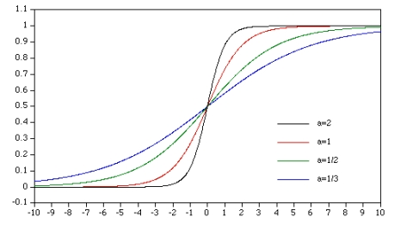
Sigmoid Function

Other activation functions can also be used →threshold function;
F(x)=1, if x>=0;
0, if x<0;

Piecewise linear function can be good option as well;

F(x) =1, if x>=1/2
x, if 1/2>x>-1/2
0, if x<= -1/2

This can also be a good research work of comparing the program with different activation functions and check the outputs.

But remember, choose such activation functions whose output has a range between 0 to 1 because it is the output which is going to be subtracted from the desired output. We are also concerned with putting a point in a particular class and the desired outputs are written in binary format(1 0 0, 0 1 0 etc).So, range of output should be between 0 and 1 to check whether a point lies near to 1 or near 0.

The activation function should be such so that if we differentiate it, the differentiated value can be represented in the program.

For e.g.: f(x) = 1/ (1 + e^{-ax});

Therefore, f’(x) = f(x)*(1-f(x)); Remember throughout the program the value of a is set to 1 to maintain non linearity; more the value of a more linear the function is.

As far as computational complexity is concerned in this program it goes in following phases;

For one training vector it first goes from input to hidden and again from hidden to output .This is repeated again backwards in same way for weight updation.

No. of multiplication for first phase: no. nodes in i/p layer(n)* no. nodes in hidden layer(h);
Complexity=O(h*n² );

No.of multiplication for 2nd phase: no.nodes in hidden layer(h)* no.nodes in output layer(ol);

Complexity=O(h*ol²);

This is repeated for all the training vectors;
But for validation phase since no. of nodes in hidden layer is increasing so complexity increases.

Now the worst case comes when no.of nodes in input and output layer becomes huge for example: if no.of nodes in input layer is 18 and no. of nodes in output layer is 23 (if there are 23 classes).
Then computations become huge. If the hardware capacity is too low the computation for such program becomes troublesome.

Hardware used:1 GB RAM, 80 GB Hard Disk,2.4 GHz Intel Processor

Platform Used:Linux(Ubuntu version 9.10)
Compiler : gcc(inbuilt in linux).

